Question 1. **Curiosity**. In the Greek myth of Pandora’s Box, a young woman (Pandora) was given a box by the Greek gods and told not to open it under any circumstances or something terrible would happen. Unfortunately, her natural curiosity got the better of her and she opened it, releasing all human evils to the world (sickness, unhappiness).

Curiosity is human drive to seek new information and Hsee & Ruan (2016) recently reported a series of studies examining whether being curious would cause people to try to resolve uncertainty even when the outcome is negative or even painful for them. Borrowing ideas from this report, a number of student groups in a research methods class tried to follow-up their findings. One of the ideas borrowed was the use of “prank pens,” which, when clicked, surprisingly deliver a mild, but aversive shock to the person holding the pen. (38 pts)

One group tried a study where participants were recruited at the student center on campus and approached by an experimenter with a prank pen who said either “this is a new kind of pen, would you like to try it?” or “we are testing this new kind of pen and will pay you $1 to test it.” More people tested the pen and received the shock when offered money.

1. What is the IV in this study? (4 pts)
2. What is the DV in this study? (4 pts)
3. What is the problem with the conclusion the students wanted to draw that “paying people made them more curious?” (4 pts)

A second group tried a different approach. Participants were recruited to do a survey to be filled out on paper. Participants were given a prank pen for the study with the warning, “the only pens we have are these prank pens that can shock you if you click them.” Half the participants were then told “be careful not to click” and the other half were told “don’t worry we took the batteries out.” Surprisingly, more participants clicked the pens and got shocked when they were warned there was a chance they could get shocked.

1. What statistical test would be used to assess a reliable effect of the IV on the DV for this study? (4 pts)
2. Does this result support the “Pandora’s box” hypothesis that curiosity can lead people to seek things that are potentially harmful? Briefly why or why not? (4 pts)

A third group based their study on a different protocol from Hsee & Ruan (2016). In this experiment, participants were seated at a computer wearing headphones. They were shown a display with buttons on the screen that were labeled ‘water’, ‘nails’ or ‘?’. If a button labeled ‘water’ was clicked, peaceful water sounds were heard. If ‘nails’ was click, a loud and unpleasant sound of nails scraping a chalkboard was played. The ‘?’ buttons randomly played one of these two sounds (50/50). In the ‘high-uncertainty’ condition, 40 of the 44 buttons were labeled ‘?’ and in the ‘low-uncertainty’ condition, 4 of the buttons were labeled ‘?’. Participants were told they could press as many or as few buttons as they wanted over a 3-minute period. The number of ‘?’ buttons pressed was scored.

1. What statistical test would be used to assess an effect of the IV on the DV in this study? (4 pts)
2. The results were reliable. Can the students say that their data support the hypothesis that higher levels uncertainty leads to more exploration (curiosity) even when negative experiences are encountered? (4 pts)
3. The experimenters noted a potential limitation. Many participants reported being bored during the 3m period and that the high-uncertainty condition seemed to complain about boredom more. What is the alternate hypothesis and how does it limit the results? (4 pts)

Question 1 (continued).

1. Each of the student projects should be done with careful attention to proper ethical research practices. Name the two most important elements you would have to clear with the IRB before running these studies. (6 pts)

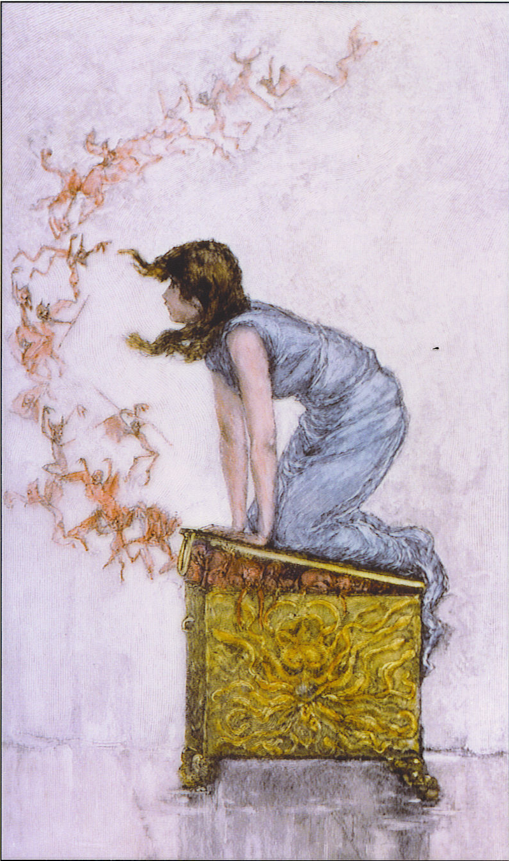

Question 2: **Healthy Behaviors.** Studies of healthy behavior often look at the influence of messages aimed at promoting both healthy eating and exercise. A research group examining these looked at the popularity of a farmer’s market specializing in healthy, organic foods immediately before and after a fitness club opened across the street. Data were available indicating the number of people who visited the market each Saturday morning and significantly more visitors to the market were observed after the fitness club opened than before the club had opened. (36 pts)

1. Is this an experimental design? Why or why not? (5 pts)
2. The researchers want to test the hypothesis that thinking about fitness increases healthy eating behavior. Give one reason why these data can’t strongly support this conclusion. (5 pts)
3. Using a banner advertising the fitness center near the farmer’s market, how could you design a simple field experiment to examine the effect of thinking about exercise on healthy food purchasing behavior? (5 pts)

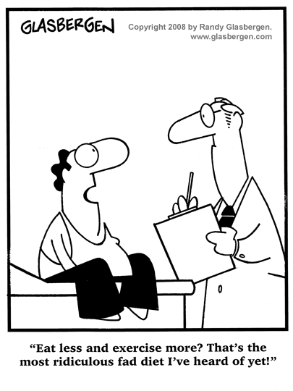

Question 2 (continued). The research group decided test the effects of newer technologies to improve health behaviors. They recruited a sample of participants interested in losing weight. Participants were randomly assigned to receive daily text messages each morning. The content of the messages varied across participants. Half the participants received a reminder to eat healthy that day. Half the participants received a reminder to exercise. The experiment ran for 4 weeks and the key measure was how much weight each participant lost over the course of the study. The experimenters hypothesized that each type of message would help with weight loss, but the combination would be particularly effective even over and above the messages independently.

1. Label the diagram of this study below and fill in the number of participants in each condition (cell) given that of the 80 participants, 20 participants got texts with both reminder messages, 19 just got eating reminders, 21 got just exercise reminders. Mark with a star the condition that got a neutral control message (a daily weather report).  
   (9 pts)

|  |  |  |  |
| --- | --- | --- | --- |
| Factor Name:  _______________ |  | Factor name: _____________ | |
|  | Level: _________ | __________ |
| Level:  _________ |  |  |
| __________ |  |  |

Question 2 (continued). Here are the results of analysis of the weight loss from SPSS:

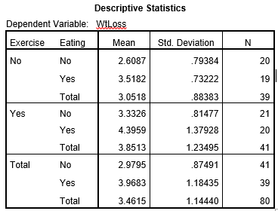 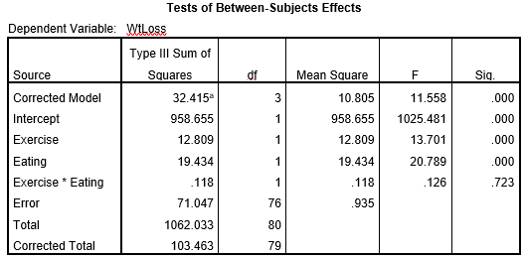

1. Write out the statistical reports of the three tests in the standard APA format including all the standard reporting statistical information. (8 points)
2. Do the results support the hypothesis of the researchers that the combination of messages would be even more effective than each type of message alone? Explain. (4 pts)

Question 3. **Pro-social behavior**. A research team wants to identify things that increase people’s pro-social behavior such as volunteering. They hypothesize that university students who live in more neighborhoods with higher density (more people) would be more likely to volunteer for charitable organizations. They were able to obtain data on a sample of students that included the density of the neighborhood in which they lived (by zip code, more dense means more people around) and the number of hours per week the students volunteered for local charities. (26 pts)

1. What statistical tool would be used to assess the association between density and volunteering? (4 pts)
2. The researchers were hoping to conclude that living in a dense neighborhood causes more volunteering. Evaluate two alternative interpretations that reflect the common issues that need to be considered with this kind of design. (4 pts)

Realizing that experimental designs are better for drawing causal inferences, the researchers set up a new study taking advantage of a summer internship program for students interested in doing charitable work. The students in the program and randomly assigned to two different dorms to live in. One dormitory had individual apartments and the other had communal bathrooms and kitchen spaces. In addition, the researchers assess all the students on an important personality trait termed Agreeableness, which indicates a person’s tendency to be cooperative, friendly and compassionate. All the participants complete a test of Agreeableness and are organized into two categories based on above average or below average scores for this sample. At the end of the summer, the participants complete a survey asking about their future volunteering plans that assesses how many hours of additional volunteering they intend to do in the next year.

1. What statistical tool would be used to assess the effects of living arrangement and high/low agreeableness on future volunteering plans in this design? (4 pts)
2. Sketch a line graph showing a potential outcome where (1) communal dorms led to higher volunteering, (2) high agreeableness led to higher volunteering and in addition, (3) the effect of the communal dorm was particularly strong. (9 pts)
3. What concern might we have about the generalizability of the results based on the specific sample of participants that were involved in the reported study? Give an example of an alternate hypothesis about a different sample. (5 pts)